MERCURY’S CRUSTAL STRUCTURE MODELING
S. Buoninfante^{1,2}, M. Milano¹, B. Negri³, C. Plainaki³, G. Sindoni³, M. Fedi¹.
¹Department of Earth, Environment and Resources Sciences (DiSTAR), University of Naples Federico II, Naples, Italy (salvatore.buoninfante@inaf.it), ²Istituto di Astrofisica e Planetologia Spaziali (IAPS), INAF, Rome,Italy, ³Agenzia Spaziale Italiana (ASI), Rome, Italy

Introduction: The study of the internal structure of Mercury is fundamental for understanding the formation and evolution of the planet and of the entire Solar System. Mercury is constituted by a very large iron-rich core with a radius of ~2000 km, a ~400 km thick mantle made of iron-poor and magnesium-rich silicates, and a silicate crust with an average thickness of ~35 km. The main purpose of this work was the analysis of the NASA MESSENGER MESS160A gravity field [1] to generate the map of the isostatic gravity anomalies of Mercury, representative of the intra-crustal sources. We first estimated a 30 km mean elastic lithosphere thickness and calculated the flexural response function of the lithosphere. Assuming a flexural compensation model, we modeled the lithospheric flexure regardless of the gravity field (e.g., [2]) and calculated the isostatic gravity anomalies by subtracting the gravity effect caused by compensating roots to Bouguer anomalies. In this way, we proved that considerable lateral density variations occur within the Mercury crust. We, then, also estimated the curst-mante interface depth, varying from 19 to 42 km.
Methods and results: Following [3], we searched for the average elastic lithosphere thickness as the one giving the best fit between observed and calculated free-air anomalies along a series of 1-dimensional profiles. In Fig. 1 we show the results obtained along a NW-SE profile. The L2 misfit between the observed and calculated data reaches its minimum at the elastic thickness of 30 km. By also evaluating the results obtained for other chosen profiles, we may assume = 30 ± 10 km as representative of the mean elastic lithosphere thickness.

Figure 1. Plot of the root mean square difference (RMS) between observed and calculated free-air gravity anomalies vs , for the NW-SE profile.

The flexural response function (Fig. 2) represents the flexural response of the lithosphere to loading and allows understanding what type of isostatic model should be considered for a given spherical harmonic degrees range. The lithosphere of Mercury flexes for spherical harmonic degrees of the topography in the range 5<l<80, i.e., for topography wavelengths ranging 190<λ<2800 km. For spherical harmonics up to degree 5 and wavelengths longer than 2800 km, the flexural rigidity D→0, and we may assume the Airy compensation model. For surface features with wavelengths shorter than 190 km, D→∞ so that no lithospheric flexure occurs since the rigidity of the lithosphere is such to resist the topographic load.

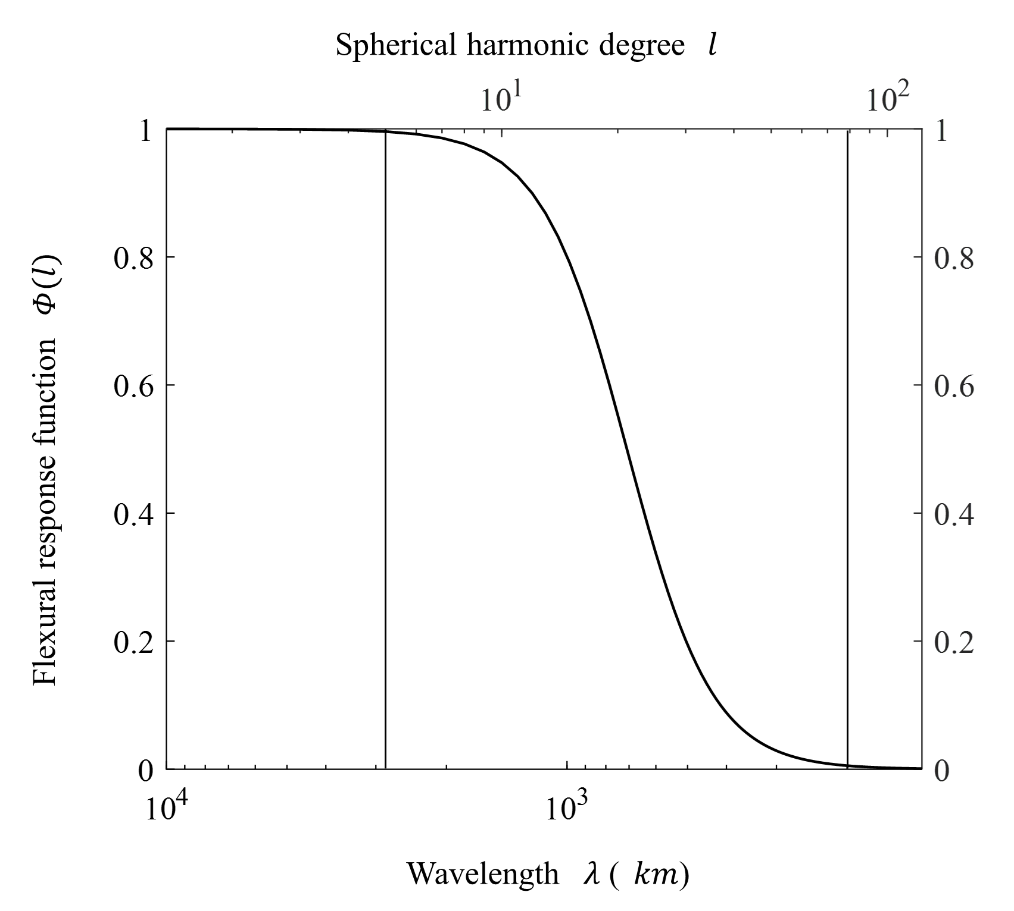

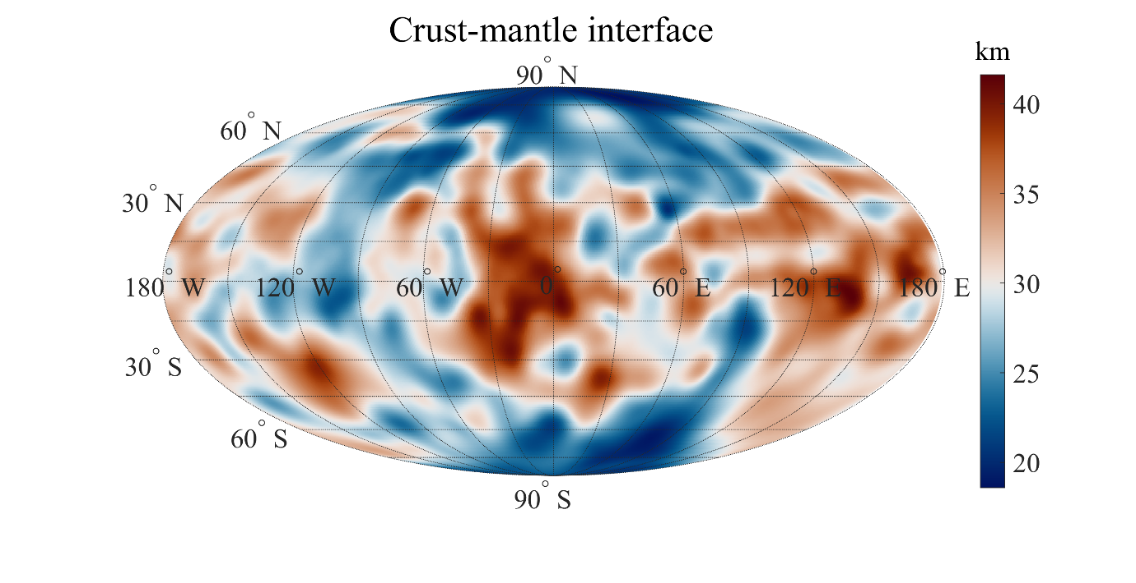
Figure 2. Flexural response function as a function of spherical harmonic degree and of topography wavelength, for the elastic thickness 30 km.

In Figure 3 we show the isostatic gravity anomalies obtained by subtracting the topographic and the isostatic gravity effects from the free-air anomalies and constrained by the MESS160A degree strength map [1], which shows the local resolution of the gravity field.

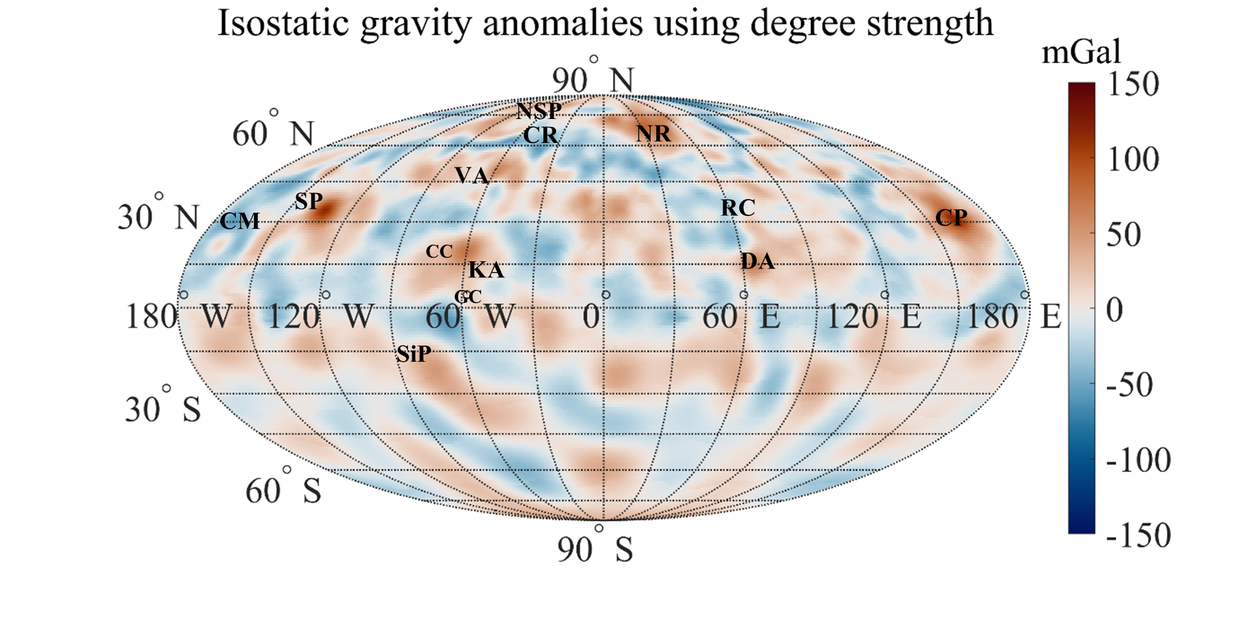

Figure 3. Isostatic gravity anomalies constrained with the MESS160A degree strength. Major features indicated are: CM = Caloris Montes; CP = Caloris Planitia; CR = Carneige Rupes; DA = Derain anomaly; KA = Kuiper anomaly; NR = Northern Rise; NSP = Northern Smooth Plains; RC = Rachmaninoff Crater; SiP = Sihtu Planitia; SP = Sobkou Planitia; VA = Victoria Anomaly; CC = Catullus Crater; GC = Giotto Crater. Maps are in Mollweide projection.

After calculating the lithospheric deflection coefficients we also modeled the crust-mantle interface (Figure 4) by means of a spherical harmonic expansion. We considered the previously estimated mean elastic thickness of 30 km and assumed densities for crust and mantle of 2800 kg/m3 and 3200 kg/m3, respectively [4].

Figure 4. Map of crust-mantle interface of Mercury, expressed as depth (km), in a Mollweide projection.

Conclusions: The isostatic gravity anomalies provide a useful tool for the geological interpretation of Mercury. The estimated mean elastic lithosphere thickness is 30 ± 10 km. The crust-mantle interface is 19 to 42 km deep. The larger crust-mantle interface depths (down to ~42 km) are reached in the equatorial regions, the smaller in the polar regions (down to ~19 km). The crustal roots thickening due to larger topographic loads is responsible for these depths. Isostatic gravity highs are mostly interpreted with intra-crustal magmatic intrusions and isostatic gravity lows as the effect of a heavily fractured crust. BepiColombo mission will provide better data resolution on the Southern hemisphere of Mercury, leading to an improved gravity field model and a more detailed isostatic gravity anomaly map.
Acknowledgements: We gratefully acknowledge funding from the Italian Space Agency (ASI) under ASI-INAF agreement 2017-47-H.0.

References:
[1] Konopliv, A. S. et al. (2020). Icarus, 335.
[2] Turcotte, D. L. et al. (1981). J. Geophys. Res., 86.
[3] Watts, A. B. (2010). Treatise on Geophysics, 6.
[4] Genova, A. et al. (2019) Geophys. Res. Lett., 46.

