DYNAMICAL STABILITY OF HIGHLY INCLINED PLANETS IN BINARY STAR SYSTEMS. F. Marzari¹ and K. Gozdziewski², ¹ Dept. of Physics and Astronomy, University of Padova, Italy, (marzari@pd.infn.it) ²ANicoulaus Kopernicus University, Torun (Poland), k.gozdziewski@umk.pl

Introduction: Exoplanets in circumprimary orbits in a binary star systems may have highly inclined orbits. Either the secondary star was born on an orbit tilted respect to the equator of the primary or dynamical mechanisms like planet-planet scattering or Kozai pumped up the inclination of putative planets. We intend to investigate the stability regions for highly inclined planets in close binary systems.
Numerical methods:We compute stability maps in semi-major axis and inclination by using MEGNO (the Mean Exponential Growth factor of Nearby Orbits [1], [2]) closely related to the maximum Lyapunov exponent. For strongly interacting systems, MEGNO converged to 2 indicates dynamical stability for the characteristic time scale of the interactions. We randomly choose the initial orbital elements of the planet(s) orbiting the primary star of the binary and integrate its orbit long enough to calculate MEGNO.
Results: Initially highly inclined orbits may lead to very high eccentricities during the anti-phased oscillations of these two orbital parameters according to the Kozai mechanism ([3], [4]). As a consequence, during the numerical integration performed to evaluate MEGNO we also compute the maximum eccentricity. If the pericenter becomes too small (smaller than the radius of the star or within a few star radii within which a strong tidal interaction is expected) we do not perform a stability analysis and we do not include that particular set of initial conditions in our stability map.
In Fig. 1 we show the stable orbits (MEGNO equal to 2) in a test system with two equal mass solar-like stars having an orbit with a_{b} = 50 au and e_{b}=0. The planet is a Jupiter-like planet with initial semi-major axis ranging from 0.05 to 35 au. The different colors give the value of the maximum eccentricity obtained during the Kozai cycle induced by the secondary star.
According to the stability map, highly inclined orbits need to be closer to the star to be stable and the critical semi-major axis reduces from about 25 au for low inclination orbits to about 15 au. Retrograde orbits appear more stable, as expected, and the critical semi-major axis extends out to about 30 au.
Mean motion resonances between the planet and the stars are clearly visible.
Future work: we are adding the effects of general relativity (GR) to the numerical integration. The forced pericenter precession induced by GR affects the Kozai cycles and it may fully inhibit them in particular for orbits where the pericenter comes very close to the star. We also plan to study multi.planet systems to test the effects of the planet mutual interactions on the long term stability.

References:
[1] Cincotta, P.~M. and Simo C. (2000), AAS 147, 205-228. [2] Gozdziewski et al (2001) A&A 378, 569-586- [3] Naoz S. (2016) ARAA 54, .441-489. [4] Lei H. (2022) AJ 163, id. 214, 15 pp.

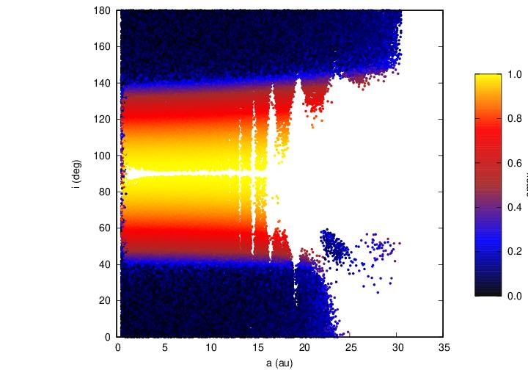
Fig. 1: stable orbits of exoplanets around the primary star. The color coding gives the maximum eccentricity reached due to the Kozai mechanism.

