SEARCH FOR SPECTRAL SIGNATURES OF ORGANICS ON THE DWARF PLANET CERES: ANALYSIS OF DATA FROM VIR SPECTOMETER OF NASA’S DAWN MISSION. S. D’Urzo¹, A. Raponi², M. C. De Sanctis³, ¹Istituto di Astrofisica e Planetologia Spaziali (IAPS), Sapienza Università di Roma, Rome (Italy) (durzo.1805501@studenti.uniroma1.it), ²Istituto di Astrofisica e Planetologia Spaziali (IAPS), Rome (Italy) (andrea.raponi@inaf.it), ³Istituto di Astrofisica e Planetologia Spaziali (IAPS), Rome (Italy) (mariacristina.desanctis@inaf.it).

Introduction: Ceres is a dwarf planet located in the main asteroid belt. NASA's Dawn mission, launched in 2007 and entered in Ceres’ orbit in 2015, collected huge amount of data of the dwarf planet using the Visible and Infrared Spectrometer (VIR) [1], Framing Cameras (FC1 and FC2) [2], and a Gamma Ray and Neutron Detector (GRaND) [3]. Thanks to the finding obtained from their data, Ceres has become an interesting target for astrobiological investigation. Ceres in fact shows a past history as an oceanic world [4] and today the traces of this past leave room for a multitude of studies. Organic matter can be identified by an absorption band around 3.4 μm in IR spectra (VIR) [5] [6] and by a redder spectral slope in the VNIR wavelengths [7]in a large region near Ernutet crater in the Northern emisphere.
In this work the "Yalode region", in the Southern emisphere, was examined, because it was indicated in a previous work by Rizos et al. [8] as a candidate to host organic material. The objective of the study was to confirm its presence through a modeling approach using the Hapke theory [9]. The main problem to address was the presence of deep carbonate bands at wavelengths of 3.4 μm superimposed to possible organics absorption. Mixtures containing materials from the medium soil of Ceres (modeled with carbonaceous chondrites [10], ammoniated phyllosilicates, carbonates) plus organics from Moroz et al. [5] and de Bergh et al. [6], were inserted into the model to discriminate between carbonates and organics and understand whether the red spectra are due to the presence of the latter or to other elements.

Methods: VIR data (IR channel 1-5 μm) consists of three-dimensional arrays called "cubes" composed of two spatial coordinates (samples and lines) and one spectral coordinate (bands) [1]. First, we investigated the cubes of the Yalode quadrangle area in search of spatial pixels that present possible signatures of organic material, i.e. with red slopes and deep absorption at 3.4 μm. We used the following spectral indicators: band area at 3.4 μm and the slope values ​​between 1 and 1.4 μm calculated as [11].
The result of this analysis are maps that allow us to identify the pixels that present redder spectra and deeper 3.4 μm bands (Fig. 1-2).

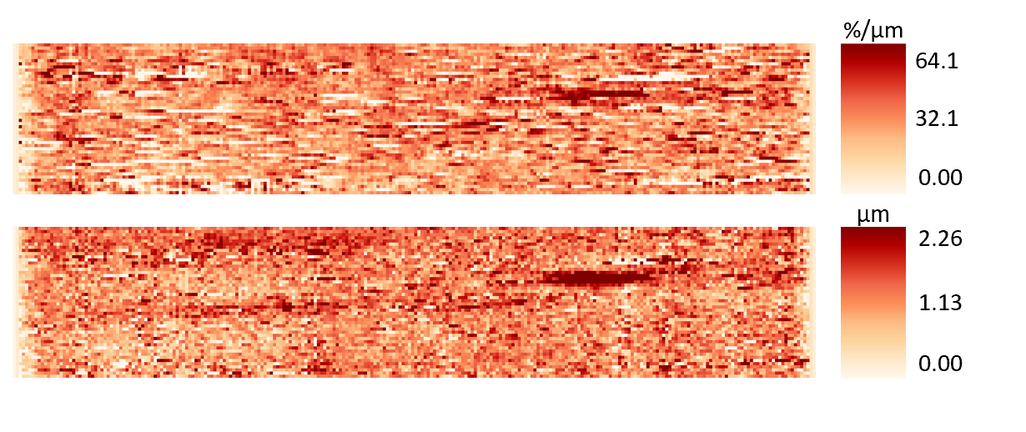
Fig 1. Analysis of spectral parameters on the cube 511958258. From the top to the bottom: slopes calculated from 1 to 1.4 μm (redder points represent redder slopes) and band areas of absorption at 3.4 μm (redder points represent higher band area values).

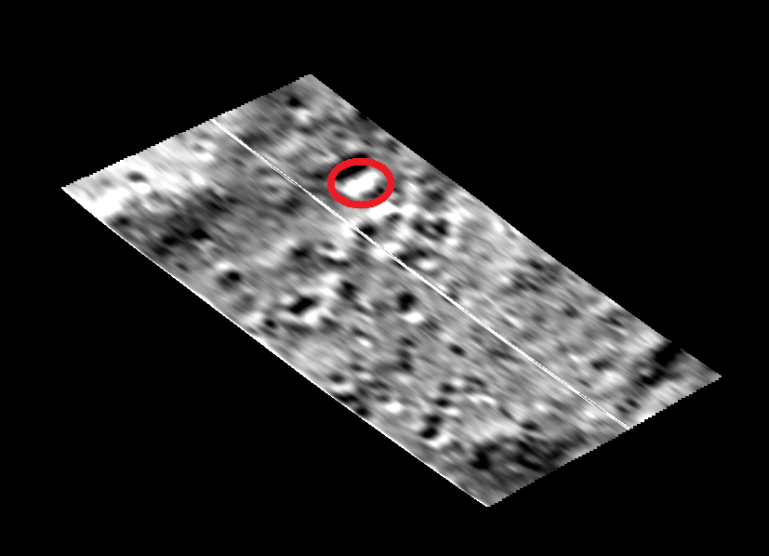

Fig 2. Projected image of the cube 511958255. The area that should contain the organics is circled in red.

We examined data from six acquisitions: 496568429 (BS1 spot in Rizos et al. [8]), 511957906, 513885720 and 579987159 (BS2 spot in Rizos et al. [8]), 511958258 and 496567078 (BS3 spot in Rizos et al. [8]). After the selection of the candidate pixels, the average signal of these was modeled with an intimate unmixing procedure which calculated the best fit between data and model [9]. For the given set of parameters, we compute I/F (the radiance factor), defined by

where ω is the single scattering albedo (SSA) computed from a linear combination of the single scattering albedos of endmembers weighed with their abundance. The SSA was calculated from optical constants (when available) or using a procedure that "inverts" the Hapke formula to calculate the SSA starting from knowledge of the reflectance signal. μ and μ₀ are the cosines of the incidence and emission angles. H(ω,µ) and H(ω,µ₀) are the Chandrasekhar integral function associated with the observation geometry [9]. B is the opposition effect contribution [9] and p(g) is the single-particle phase function [10]. The free parameters of the model are: the weights of the various endmembers (whose reflectances were taken from the RELAB spectral database), the grain sizes of the components whose SSA was calculated starting from the optical constants, the factor in effective emissivity (parameter which takes into account the roughness of the ground) [12] and the temperature used in the removal of the thermal emission signal which dominates longward of 4 μm, an additional slope and, finally, a multiplicative factor that lowers the model signal compared to that of the data. The slope and the multiplicative factor correct the model for uncertainties in the calibrated signal and photometric parameters [13]. The endmembers used are: carbonaceous chondrites and magnetite as dark component [14], siderite, magnesite and dolomite as carbonates, antigorite and NH4-montmorillonite as phyllosilicates and various organic materials taken from the article of Moroz et al. (1998) [5] and de Bergh et al. (2008) [6] (Fig. 3).

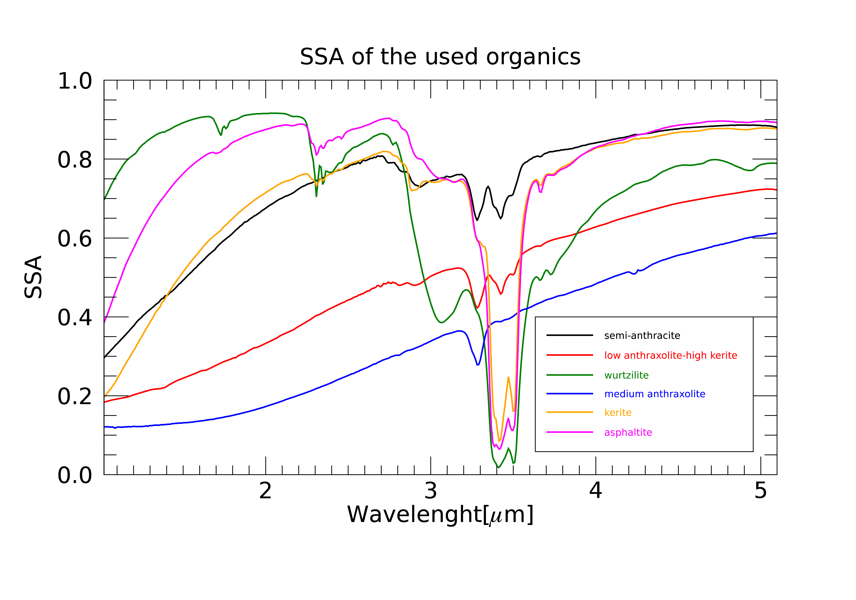
Fig 3. SSA of the organics used in this work.

Results: Using the method just described, several tests were carried out by mixing the various endmembers in order to obtain the best fit between data and model. This analysis was done for all the selected acquisitions in order to obtain the mineralogical composition of the spots showing the reddened spectra. At wavelengths greater than 4.1 μm the data were discarded because at those values ​​the thermal effect dominates the spectrum. Also, the data in the following wavelength ranges: (1.4-1.5 μm), (2.4-2.6 μm), (3.7-3.8 μm) were discarded because at these values the filter junctions produce an
unreliable signal. Error bars are estimated qualitatively by observing the amplitude of the signal fluctuations (Fig. 4).

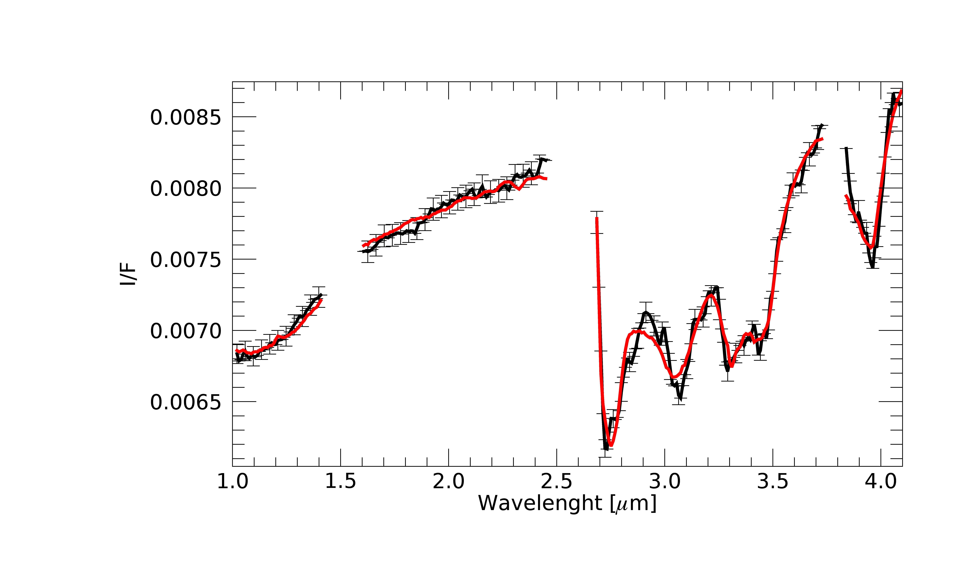Fig 4. Measured (black) and modeled (red) average spectrum of the spot BS2 using data from cube 579987159 in terms of I/F (r × π).

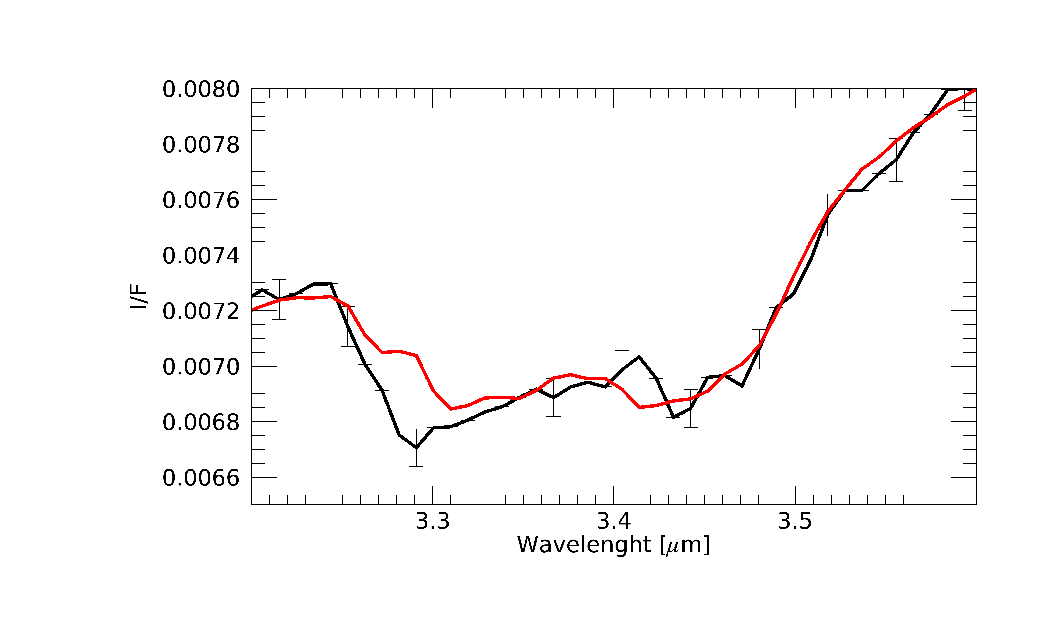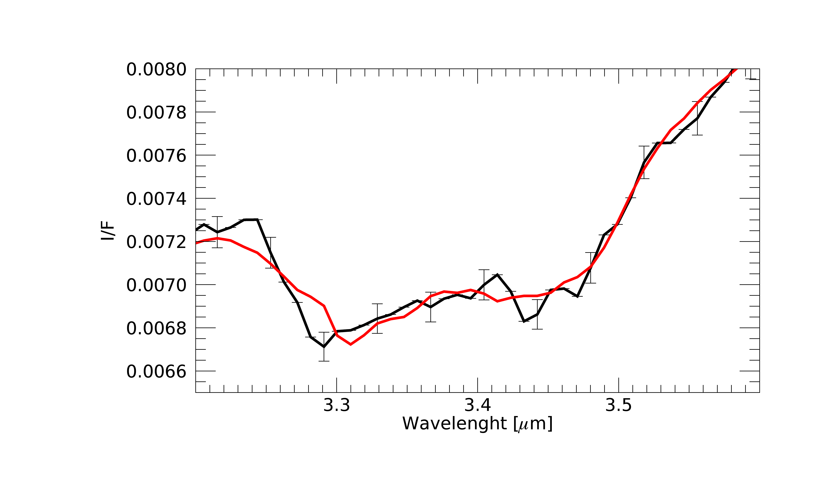
Fig 5. Measured (black) and modeled (red) spectrum of acquisition 579987159. Left: absorption at 3.4 μm without organic component. Right: absorption at 3.4 μm with organic component.

The best model is obtained by using wurtzilite [5] and medium anthraxolite [5] as organic component which provide a better fit to the absorption at 3.4 μm (Fig. 5) and the slope in the VNIR. These organic materials are different with respect that used to interpred the intense absorption in the Ernutet crater [15]. Moreover, Fe-carbonate (siderite) and Mg-carbonate (magnesite) are also new entry in the inventory of Ceres minerals suited to model global and localized regions on the surface of Ceres. This is a further confirmation of the complex (organic) chemistry present on the surface of Ceres.

References: [1] De Sanctis et al. (2011) Space Sci. Rev. 163, 329–369. [2] Sierks et al. (2011) Space Science Reviews 163, 263–327. [3] Prettyman et al. (2011) Space Sci. Rev. 163, 371–459. [4] De Sanctis et al. (2020) Space Sci. Rev. 216, 4-60. [5] Moroz et al. (1998) Icarus 134, 253–268. [6] de Bergh et al. The Solar System Beyond Neptune, 483-506. [7] Pieters et al. (2018) Meteoritics & Planetary Science 53, 1983- 1998. [8] Rizos et al. (2023). [9] Hapke (2012) Cambridge University Press. [10] Ciarniello et al. (2017) Astronomy & Astrophysics 598. [11] Raponi et al. (2016) Monthly Notices of the Royal Astronomical Society 462, 476-490. [12] Davidsson et al. (2009) Icarus 201, 335-357. [13] Raponi et al. (2019) Icarus 320, 83-96. [14] Kurokawa et al. (2020) Journal of Geophysical Research: Planets 125. [15] De Sanctis et al. (2017) Science 355, 719-722.

